# Use Cases

**Actors for all Use Cases are User only.**

1. **Create Account**

| Description | Shows how the process for creating an account works. |
| --- | --- |
| Pre-condition | User has opened the application and is on the welcome/home page |
| Post-condition | The user has successfully created an account |
| Actions/Interaction Steps | 1. User presses the ‘Create Account’ button 2. User is prompted (by a pop-up) for a valid email address and password 3. User enters valid email and password and presses submit |
| Exception (Problems) + Interaction Steps | #1 User doesn’t want to create an account:   1. User can press the ‘Continue as guest’ button.   #2 Pop up doesn’t load:   1. User can press the ‘Not loading? Click to refresh’ button 2. User can re-try the ‘Create Account’ button   #3 User does not enter valid email and/or password   1. User is presented with error message and prompted to re-enter valid email and/or password |

1. **Log In**

| Description | Shows the process for logging in. |
| --- | --- |
| Pre-condition | User has opened the application and is on the welcome/home page |
| Post-condition | The user has successfully logged in. |
| Actions/Interaction Steps | 1. User presses the ‘Login’ button 2. User is prompted (by a pop-up) for their login details 3. User enters login details and presses the ‘Submit’ button |
| Exception (Problems) | #1 User wants to continue as guest:   1. User presses the ‘Continue as a guest’ button   #2 Pop up doesn’t load:   1. User can press the ‘Not loading? Click to refresh’ button 2. User can re-try the ‘Create Account’ button   #3 User enters incorrect login details:   1. User is presented with error message ‘Incorrect Login Details’ and prompted to re-enter details. |

1. **Create/Submit a Prediction**

| Description | Shows the process for creating and submitting a prediction for a football match between 2 teams |
| --- | --- |
| Pre-condition | User has logged in and is on the home page for predictions |
| Post-condition | User is presented with the predicted outcome for their selected teams/variables |
| Actions | 1. User selects 2 teams, one from each dropdown menu: ‘Team 1’ and ‘Team 2’ 2. Match prediction/score is default but user can select additional variables to predict by clicking ‘Add Variable’ button. Skip to #4 if no additional variables. 3. User is presented with dropdown menu of variables and selects one 4. User presses the ‘Submit’ button |
| Exception (Problems) | #1 User selects only one team or the same team, twice:   1. User is shown error message and prompted to re-select teams   #3 User selects wrong variable   1. User can press the ‘delete’ button next to variable and re-select.   #4 Prediction doesn’t load or there is another error:   1. User is prompted to refresh the page and begin from step #1. |

1. **Edit Favourite Team(s)**

| Description | Process for how a user can edit the ‘Favourite Teams’ list. |
| --- | --- |
| Pre-condition | User has logged on to their account and has navigated to the ‘User Profile’ page. |
| Post-condition | User has the ability to edit (Add/Delete) their ‘Favourite Teams’ list in some way. |
| Actions | 1. Under the ‘Favourite Teams’ list, user presses the ‘Edit’ button. |
| Exception (Problems) | #1 The button fails to work:   1. User is presented with an error message and prompted to reload the application |

1. **Save a Default Prediction**

| Description | Shows the process for saving a default prediction template (concerns the prediction variables only and NOT the teams) |
| --- | --- |
| Pre-condition | User is on the main prediction page and has selected all of the variables they wish to be default. |
| Post-condition | The selected variables are saved as default variables and will now load for every future prediction |
| Actions | 1. User presses the ‘Save as Default Variables’ button. |
| Exception (Problems) | #1 User has selected teams in addition to variables:   1. User is presented with error message stating ‘No Teams Allowed’ and the teams values are cleared 2. User repeats step #1 with no teams. |

# Use Case Diagram + Analysis

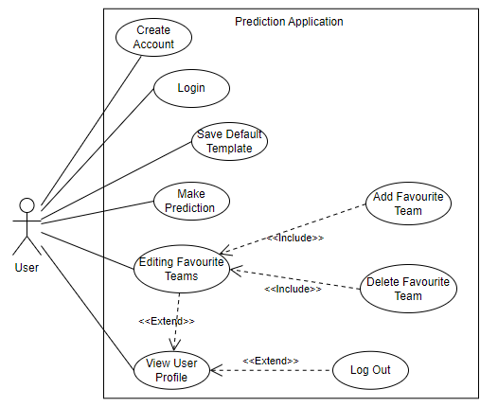

The Use Case Diagram was relatively easy to construct because, as you can see from the diagram, there aren’t too many use cases and the application has a very simple functionality. Therefore, there aren’t too many relationships (include and extend) between use cases. To Add and Delete teams from the Favourite Teams list, you have to edit the Favourite Teams list first, therefore an Include relationship (they are also mandatory Use Cases, if you edit the list then you have to do one of the two). Editing the Favourite Teams list and Log Out are both optional Use Cases that come as a result of viewing the user profile hence the Extend relationships.

Extra Use Case Table Info In case we have space

Add Team:

1. User is presented with dropdown menu with all available teams
2. User selects team by clicking on their name

Delete Team:

2) User presses the ‘Delete’ button next to incorrect team name.

#3 User selects wrong team:

1. User follows Delete Team step #2 above and presses the ‘Delete Button’.
2. User repeats process from step #1 and selects correct team.

Delete Team #2 User deletes wrong team:

1. User repeats process from step #1 to re-add team.